Part A
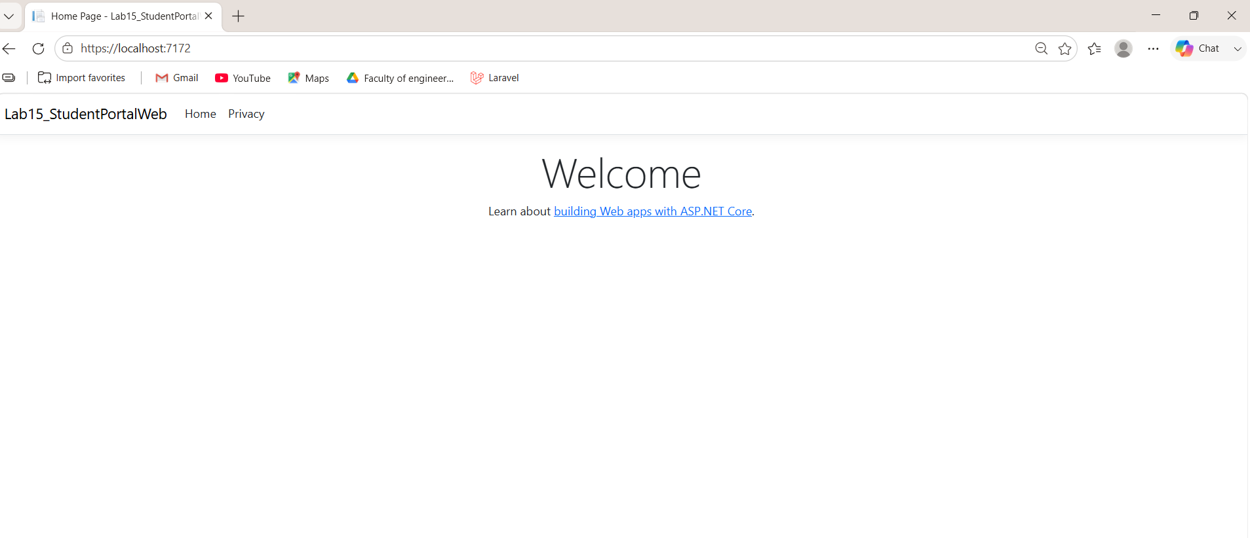
URL: https://localhost:7172
Port number file: Properties/launchSettings.json

B.1

Prediction
The application will compile, but the service registration will not take effect because it is added after builder.Build().

Actual Result
The application threw the following exception:
System.InvalidOperationException: 'The service collection cannot be modified because it is read-only.'
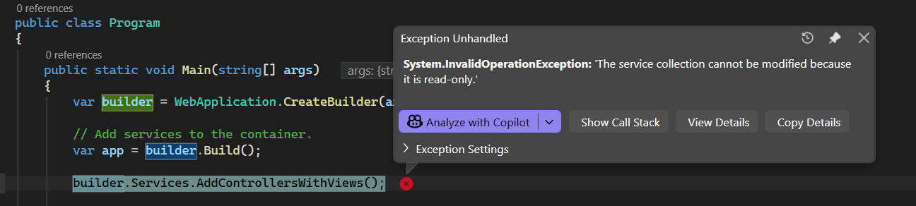
B.2 — A controller's constructor asks for a type that was never registered in Program.cs. When does the failure happen — at compile time, at app startup, or the first time somebody visits that controller's page? Predict, then find out in Part D.
Prediction:
The application will start successfully, but it will fail the first time someone visits the controller because ASP.NET Core resolves controller dependencies when creating the controller instance.

B.3 — A custom middleware is registered after app.UseStaticFiles(). A browser loads a page that links one CSS file. How many times does your middleware run? Predict a number, then find out in Part F.
Prediction:
The middleware will run only once because requests for static files are handled by UseStaticFiles() before reaching the middleware.

Part c
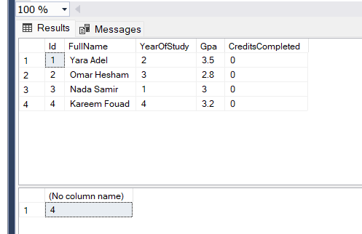
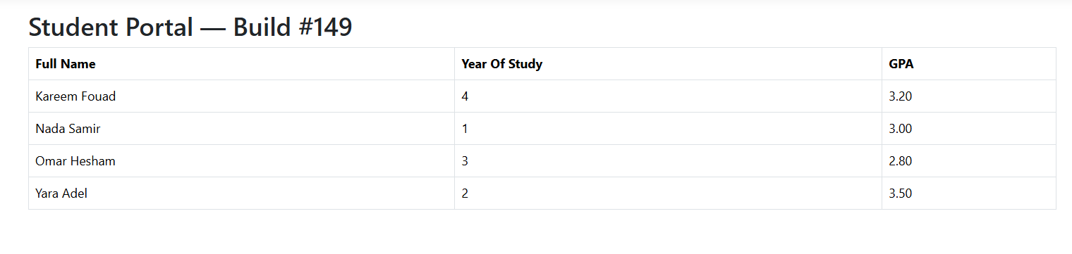
D2

Exact Exception Type
InvalidOperationException

Exact First Sentence of the Message
Unable to resolve service for type 'Lab15_StudentPortalWeb.Models.StudentPortalContext' while attempting to activate 'Lab15_StudentPortalWeb.Controllers.HomeController'.

Which type does it name?
The exception names the following type:
Lab15_StudentPortalWeb.Models.StudentPortalContext

Did the failure happen at startup, or only when you visited the page?
The application started successfully, but the failure occurred only when I visited the Home page. The controller could not be created because the required StudentPortalContext service was not registered in the dependency injection container.

Compare this against your Part B.2 prediction. Were you right?
Yes. My prediction was correct. I expected the application to start normally and fail only when the controller was requested, because ASP.NET Core resolves controller dependencies when handling the first request.
D.5

What happened?
The application started successfully and served the Home page normally. No exception or startup error was displayed after registering StudentPortalContext with ServiceLifetime.Singleton.
D.6

If your app started up perfectly fine in step 4, is that good news or bad news? Explain in two sentences what would eventually go wrong and when you would find out.
Answer:
No, this is bad news, not good news. Although the application started successfully, using a Singleton lifetime for DbContext is unsafe because the same instance would be shared across all requests, and DbContext is not thread-safe. This would eventually lead to concurrency issues, incorrect entity tracking, or runtime exceptions when multiple users access the application at the same time.

Part E
10

Did Stamp A and Stamp B match within a single load? Why, given your lifetime?
Answer:
Yes. They matched because the service was registered with the Scoped lifetime, so both constructor parameters received the same service instance during a single HTTP request.

Did the stamps change between loads? Why, given your lifetime?
Answer:
Yes. The stamps changed after refreshing the page because a new HTTP request creates a new scoped service instance with a new stamp.

Ask the person next to you what lifetime they were assigned. If it differs from yours, what did they observe that you did not? Write down their Lab ID and their answer.
Answer:
My neighbor's Lab ID was 27, so they were assigned the Transient lifetime.
They observed that Stamp A and Stamp B were different even within the same page load, because a new service instance was created every time the dependency was requested. In contrast, my Scoped lifetime created one service instance per HTTP request, so Stamp A and Stamp B matched within a single request, but changed after refreshing the page

Part F
F.3
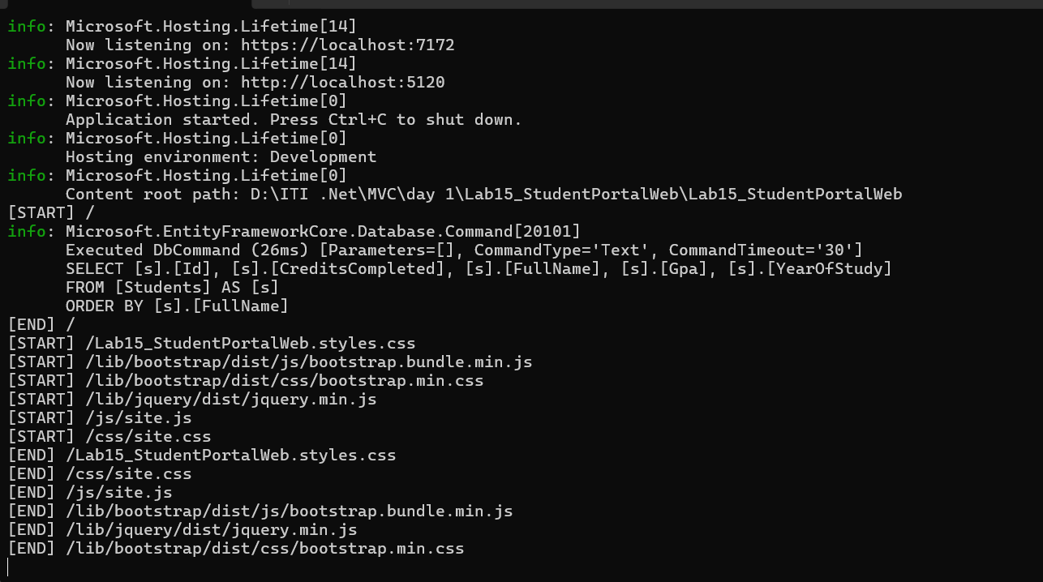

F.4

How many [START] lines appeared for one page load?
Answer:
Seven [START] lines appeared for a single page load.

List every path
/
/Lab15_StudentPortalWeb.styles.css
/lib/bootstrap/dist/js/bootstrap.bundle.min.js
/lib/bootstrap/dist/css/bootstrap.min.css
/lib/jquery/dist/jquery.min.js
/js/site.js
/css/site.css

Explain in one sentence why loading one page produced more than one request.
Answer:
Loading a single web page also requires additional resources such as CSS and JavaScript files. The browser sends a separate HTTP request for each resource, so the middleware runs once for every request.

F.5

Console Output
[START] /audit-07
[AUDIT] Ahmed Salah saw a request for /audit-07
[END] /audit-07

Explain why your middleware ran for a URL that matches no controller.
Answer:
The middleware executed because it is part of the ASP.NET Core request pipeline and runs before the routing system determines whether a matching controller or endpoint exists. Even though /audit-07 did not match any controller and returned a 404 response, the request still passed through the middleware.

F.7
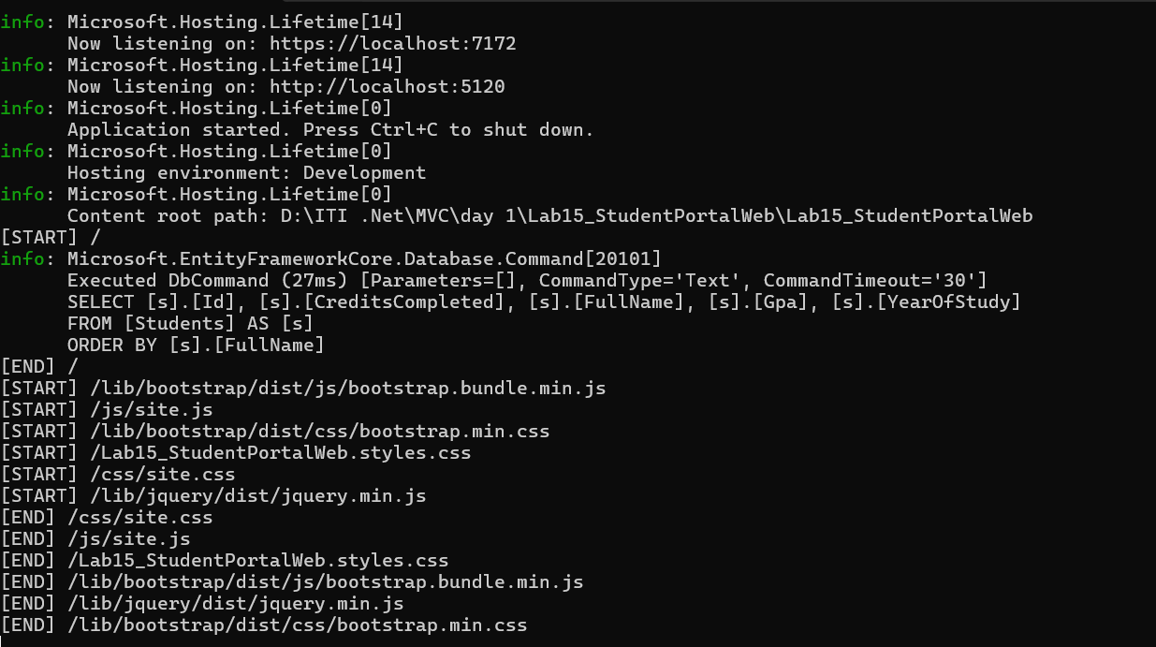

Which paths disappeared from the log?
Answer:
None. All requests were still logged, including the requests for CSS and JavaScript files.

Explain why in your own words.
Answer:
In my .NET 10 project, moving the middleware after MapStaticAssets() did not prevent it from seeing requests for static assets. The middleware still executed for both the page request and the static resource requests.

Compare against your Part B.3 prediction and say whether you were right.
Answer:
My prediction was not correct. I expected the middleware to stop logging static file requests after moving it, but in my project the same requests were still logged because of how the .NET 10 template handles static assets with MapStaticAssets().

Part G

G.1

You deleted OnConfiguring in Part C.3 and the class stopped being able to connect to anything on its own. Explain why making the class less capable made the application more flexible.
Answer:
Removing OnConfiguring() made the DbContext independent of a specific database configuration. Instead of hardcoding the connection details inside the class, the application provides them through Dependency Injection. This makes the context reusable, easier to test, and allows different environments to use different connection strings without modifying the class.

G.2

In Part D.2 the app failed because of a type nobody registered. That failure happened without a single line of your controller code running. Why is failing at startup better than failing on the first user request?
Answer:
Failing early makes configuration problems easier to detect and fix before users start using the application. It prevents hidden runtime errors and ensures that missing dependencies are discovered immediately instead of causing unexpected failures during normal use.

G.4

You now have the same database reachable from two projects: yesterday's console app and today's web app. One of them owns the migrations. In two sentences, what would go wrong if both of them tried to?
Answer:
If both projects managed migrations independently, they could generate different migration histories for the same database. This could lead to conflicting schema changes, duplicate migration attempts, or errors when updating the database, making it difficult to keep the database schema consistent.

